GAM 508 – Scran Dash – Reflective Essay – January 5th 2026

This is a reflective essay that centers on describing the design process and the following production of the prototype of the game Scran Dash. I go through the design, planning and making of the game prototype, concluding with reflections on how we could have done things better as a team, and what I learned from the whole experience.

Design Process

The whole-team design process began with discussions about a core mechanic that we could build out a game around. The idea that netted me the role of Design Lead was a whimsical idea for a cozy game that would be a cross between Katamari Damacy (Namco, 2004) and Untitled Goose Game ( House House, 2019). Set in the grounds of a gothic mansion, the player takes on the role of a hedgehog dad who needs to effect mastery of his environment in order to provide for a passel of adorable hoglets that need his care. It just so happens that the hedgehog dad has made his family’s den in the mausoleum of a magic user who was buried with their spellbook – so the player has access to spells and enchantments, adding to the whimsy as well as the depth of the game.

The core gameplay mechanic of this idea was what attracted the other team members the most, one where the player hedgehog rolls up into a ball to pick up food and items. It’s charming, whimsical and most importantly suited to being made in the Unity game engine, which was one of our key design requirements. The idea of hedgehogs gathering things using their spines has a long history, but my belief is that there is no such thing as a ‘new’ idea under the sun and the success of any game design idea is all in the execution. Using the local British (mostly North of England) slang descriptor word ‘scran’ to describe the base currency of the game’s resource management system is a touch of genius that I can ascribe to team member Megan whose grasp of the local vernacular is stronger than mine. We alighted upon it as a way to tie the game tighter to its British setting and origins.

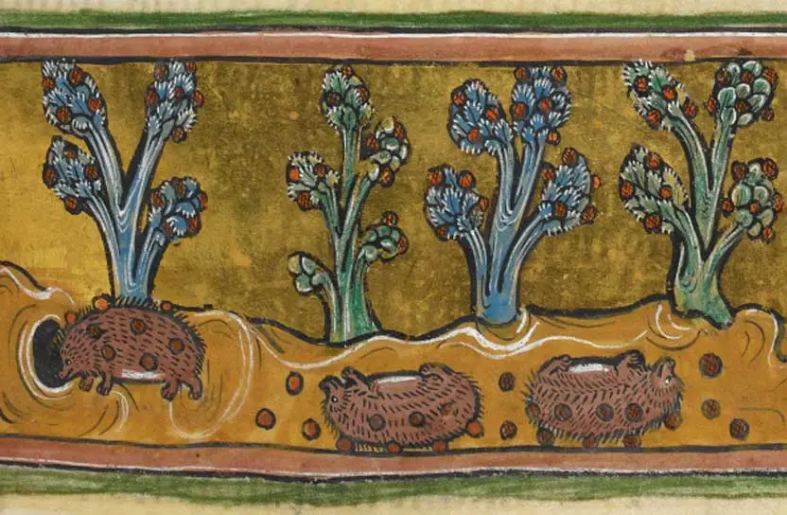

[ A medieval illustration of hedgehogs rolling around on grapes and gathering them with their spines]

Planning Process

Having set down our game idea roughly on a one-page GDD, we set about allocating areas of responsibility. One of the things I regret the most about the format of this year’s collaboration focused modules is that whenever students are asked to work in a group it leaves absolutely no time for personal learning or exploration of skills that are not in the ‘comfort zone’ of any particular team members. Therefore, on the basis of our core strengths as individuals, we decided Kieran would be responsible for designing and programming the resource management game loop, Virginia would design and program the UI and player movement, rolling and pickup mechanic, and Megan would focus on the game art. I, as Design Lead, would take on the majority of the heavy lifting of writing the final Game Design Document, especially the design of the setting, narrative and backstory.

As it happened, two team members suffered illness and one team member, Kieran, dropped out of the project entirely, which were just challenges that we as a whole team had to face and overcome. Agile methodology emphasizes responding to changing circumstances with flexibility rather than sticking rigidly to a fixed plan. So the prototype we produced doesn’t have the entire game loop associated with a richly detailed, intricately balanced resource management aspect that Kieran and I had envisioned, but we have added UI elements and gameplay elements that nod to that aspect and acknowledge that it will feature in future iterations of the game prototype. We downs-scoped the project in response to the change in circumstances.

The process of production was supported by our use of Codecks as a planning and management tool. It helped us remain on clear terms with each other about what we were doing in between scrum meetings, which we held weekly. It also helped us track our progress and agree to team deadlines. The assignment was to work as if we were in a AAA environment, so we made use of Github for version control. It bears repeating that version control is a brilliant and effective way to work on complex software projects as a team. Where builds fail, you can use version control to roll back to a previous build. Where bugs surface, finding them is easier where you can look back to previous builds for where in the process things started to break, or to branch off a version so that you have a safe space to experiment with fixes that doesn’t endanger the whole entire project. As evidenced in our extensive use of ‘branching’ and duplicating the project, we as a team relied heavily on GitHub to do things to the project individually and then merge all our work each week into our weekly build. That’s not to say it is a perfect solution, we still managed to come across teamworking difficulties such as loss of work because of merge conflicts.

Team communication was a big bugbear for me as Design Lead

The Build Itself

Final Thoughts

References

https://www.idler.co.uk/article/the-myth-of-the-grape-eating-hedgehog/

Link to Codecks Project Management Tool Page for Scran Dash

Link to Github Repo

